**REPORT**

**Q. 1) Find all the unique 'Wind Speed' values in the data.**

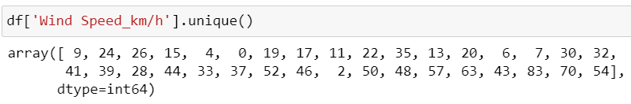

**Explanation:**

For finding the unique Wind Speed values I use ‘**unique()**’ function on ‘Wind Speed’ column to get the array of unique values in Wind Speed column.

**Q. 2) Find the number of times when the 'Weather is exactly Clear'.**

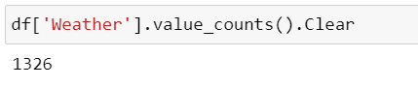

**Explanation:**

For finding the number of times when the ‘Weather is exactly Clear’ I use ‘**value_counts()**’ function on ‘Weather’ column and value is ‘Clear’.

**Q. 3) Find the number of times when the 'Wind Speed was exactly 4 km/h'.**

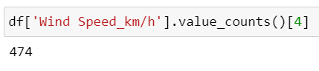

**Explanation:**

For finding the number of times when the ‘Wind Speed was exactly 4 km/h**'** I use ‘**value_counts()**’ function on ‘Wind Speed’ column and value is ‘4’.

**Q. 4) Find out all the Null Values in the data.**

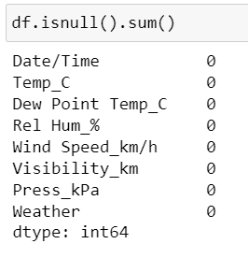

**Explanation:**

For finding the all the null values in the data I use ‘**isnull()**’ function on df data and ‘**.sum()**’ function to get number of null values in each column.

**Q. 5) Rename the column name 'Weather' of the data frame to 'Weather Condition'.**

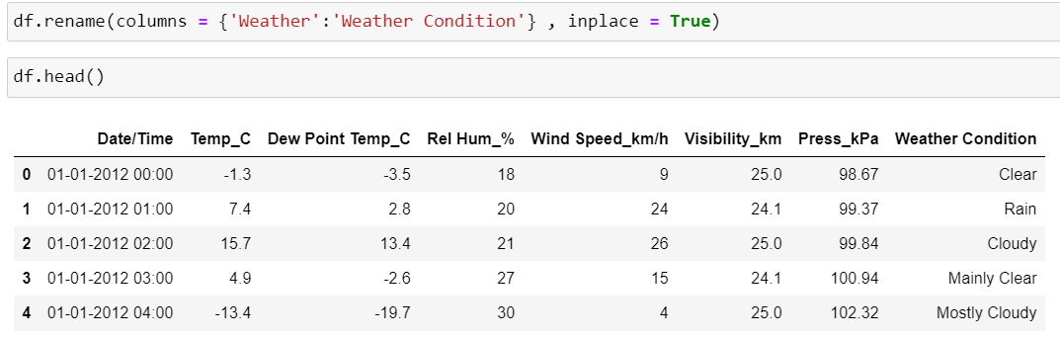

**Explanation:**

For renaming the column name ‘Weather’ to ‘Weather Condition’ I use ‘**rename()**’ function in that function we should give **columns** name as dictionary with key as present column name and value as new column name and **inplace = True** gives permanent change of column name in data frame.

**Q. 6) What is the mean 'Visibility'?**

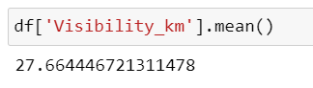

**Explanation:**

For calculating the mean ‘visibility’ I use ‘**mean()**’ function on ‘Visibility’ column.

**Q. 7) What is the Standard Deviation of 'Pressure' in this data?**

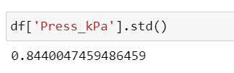

**Explanation:**

For calculating the Standard Deviation of ‘Pressure’ I use ‘**std()**’ function on ‘Pressure’ column.

**Q. 8) What is the Variance of 'Relative Humidity' in this data?**

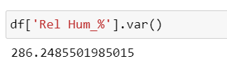

**Explanation:**

For calculating the Variance of ‘Relative Humidity’ I use ‘**var()**’ function on ‘Relative Humidity’ column.

**Q. 9) Find all instances when 'Snow' was recorded.**

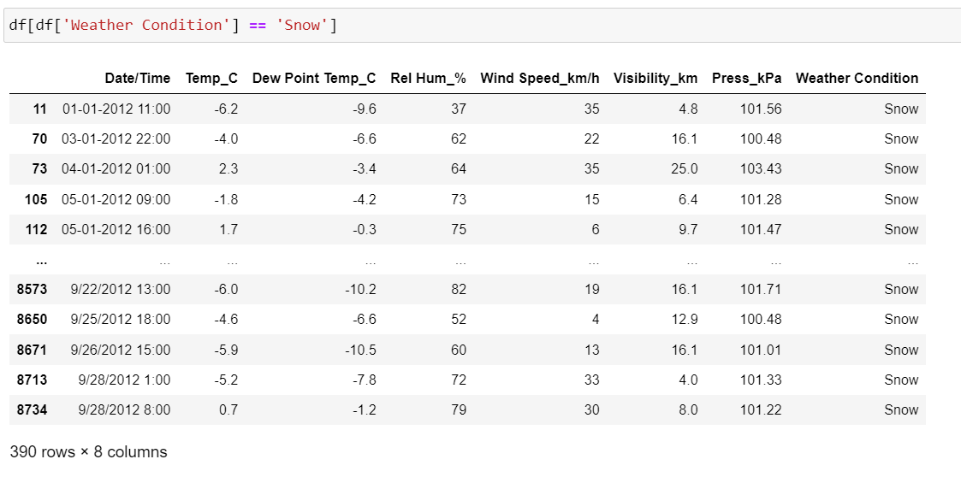

**Explanation:**

For finding the all instances when ‘Snow’ was recorded I use ‘**==**’ comparison operator on ‘Weather Condition’ column and the value is Snow.

**Q. 10) Find all instances when 'Wind Speed is above 24' and 'Visibility is 25'.**

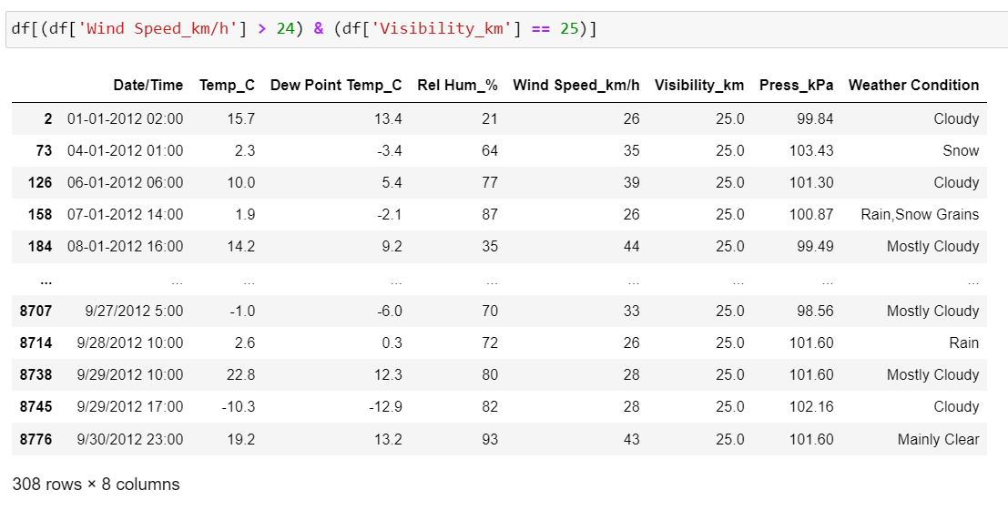

**Explanation:**

For finding the all instances when ‘Wind Speed is above 24 and visibility is 25’ I use ‘**>**’ comparison operator on ‘Wind speed’ column with the value is 24 and **‘==**’ comparison operator on ‘Visibility’ column with the value is 25 and also ‘**&**’ logical operator to satisfy the both conditions.

**Q. 11) What is the Mean value of each column against each 'Weather Condition?**

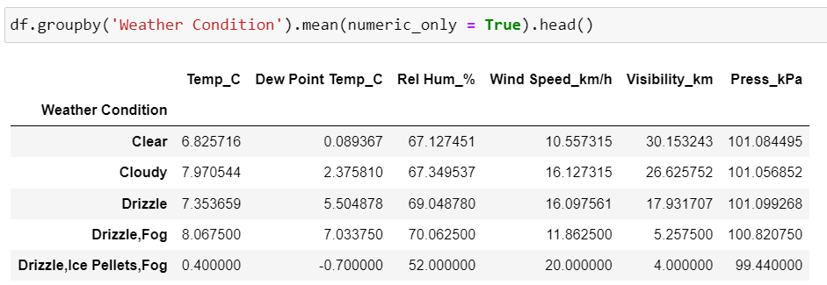

**Explanation:**

For finding the mean value of each column against each ‘Weather Condition’ I use ‘**groupby()**’ function on ‘Weather condition’ column and for mean I take aggregate function ‘**mean()**’.

**Q. 12) What is the Minimum & Maximum value of each column against each 'Weather Condition?**

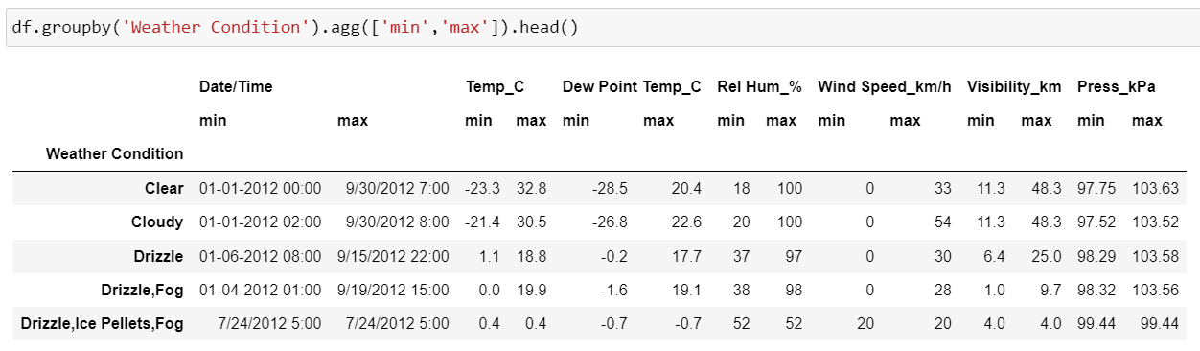

**Explanation:**

For finding the minimum & maximum value of each column against each ‘Weather Condition’ I use ‘**groupby()**’ function on ‘Weather condition’ column and for minimum and maximum I take aggregate function ‘**agg([’min’,’max’])’**.

**Q. 13) Show all the Records where Weather Condition is Fog.**

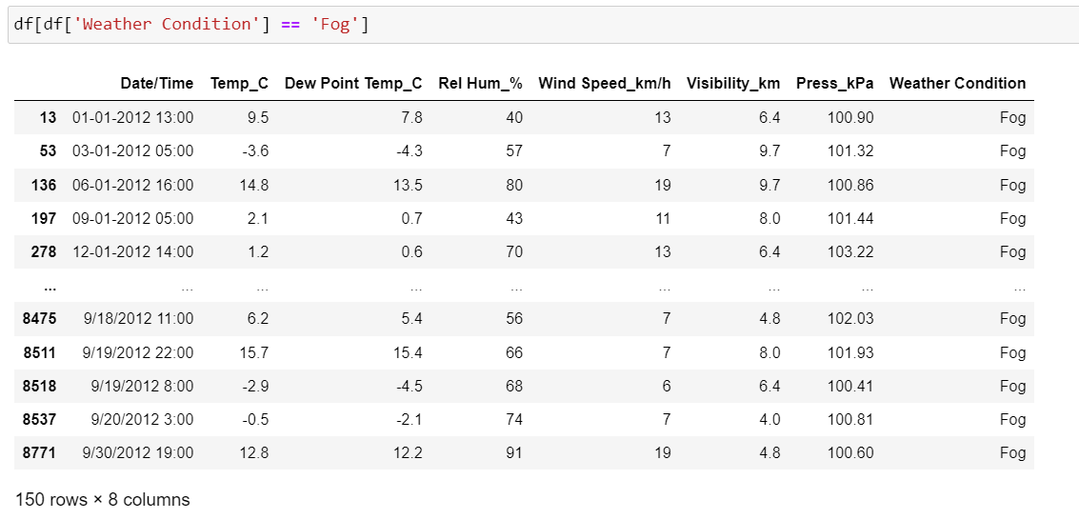

**Explanation:**

For showing the all records where ‘Weather Condition’ is Fog I use ‘**==**’ comparison operator on ‘Weather Condition’ column and the value is Fog.

**Q. 14) Find all instances when 'Weather is Clear' or 'Visibility is above 40'.**

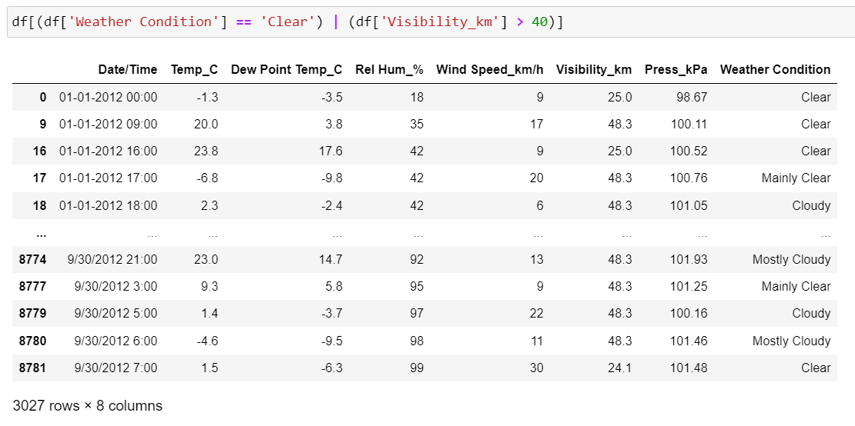

**Explanation:**

For finding the all instances when ‘Weather is Clear or visibility is above 40’ I use ‘**==**’ comparison operator on ‘Weather Condition’ column with the value is Clear and **‘>**’ comparison operator on ‘Visibility’ column with the value is 40 and also **‘|**’ logical operator to satisfy the either one condition.

**Q. 15) Find all instances when:**

**A. 'Weather is Clear' and 'Relative Humidity is greater than 50'**

**or**

**B. 'Visibility is above 40'.**

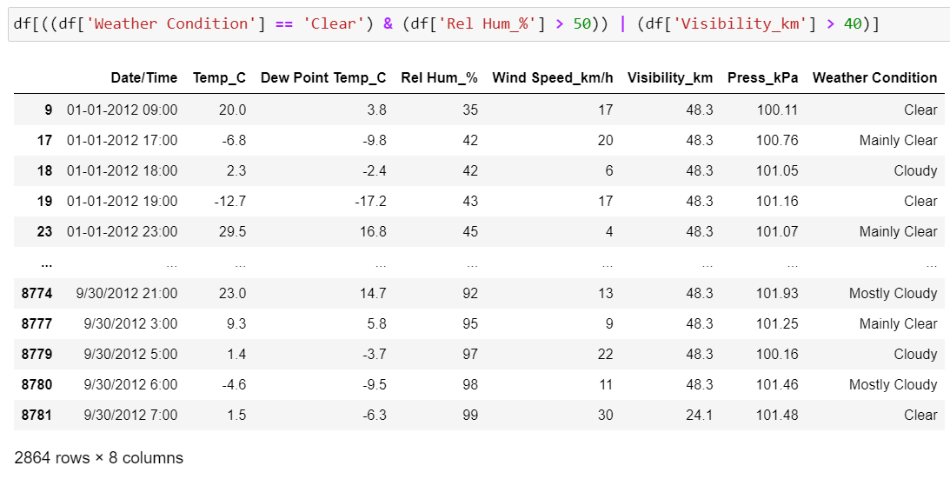

**Explanation:**

For finding the all instances when ‘Weather condition is clear and Relative Humidity is greater than 50’ I use ‘**==**’ comparison operator on ‘Weather Condition’ column with the value is Clear and **‘>**’ comparison operator on ‘Relative Humidity’ column with the value is 50 and also ‘**&**’ logical operator to satisfy the both conditions for case_1 and ‘Visibility is above 40 I use ‘**>**’ comparison operator on ‘Visibility’ column and the value is 40 for case_2 and in between the case_1 and case_2 there is ‘**|**’ logical operator to satisfy the condition of either case_1 or case_2.